**BRAC University**

**Department of Computer science and engineering**

Subject: CSE 422 Title: Artificial Intelligence

Marks : 60 Time: 3h

Answer any 6.

1. 2+3+5
   1. What are differences between “thinking humanly” and “thinking rationally”?
   2. Show examples of different environments which largely effects on agent design.
   3. In case of ‘Chess’, ‘Room scheduling’ and ‘Adaptive examination’ what type of agents you will choose? Defend your answer.
2. 2+3+5
   1. State properties (in terms of completeness, time, space and optimality) of DFS and BFS.
   2. Explain the following hill climbing search algorithm.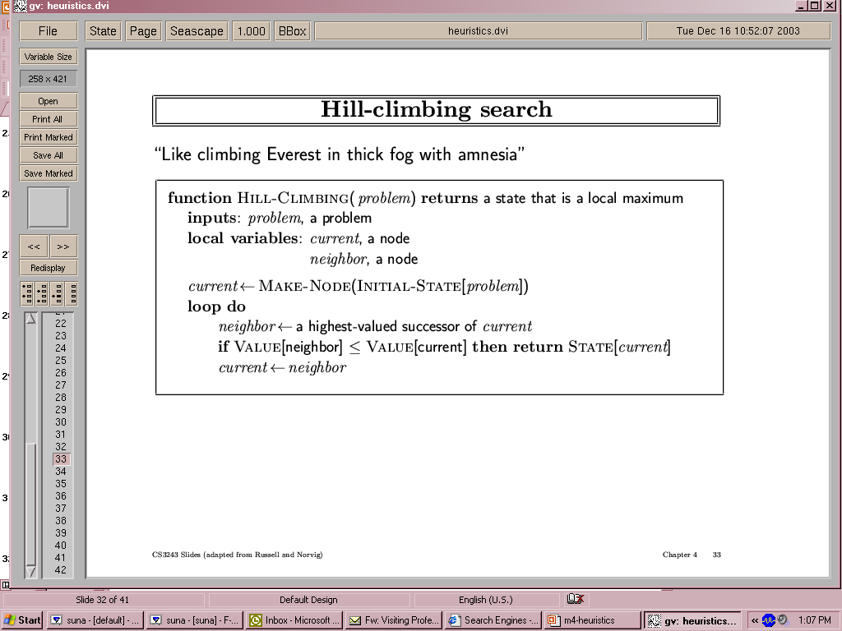
   3. Apply A* search algorithm for the following graph to reach Bucharest from Zerind. What will be the huristic for this algorithm?

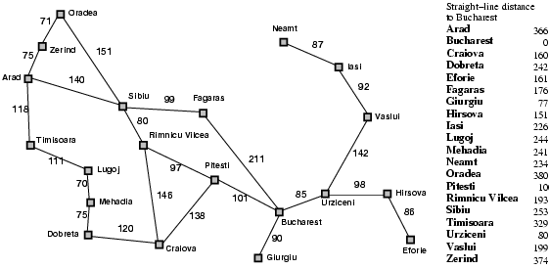

1. 2+3+5
   1. What are major issues you should face in case of game and search problem?
   2. 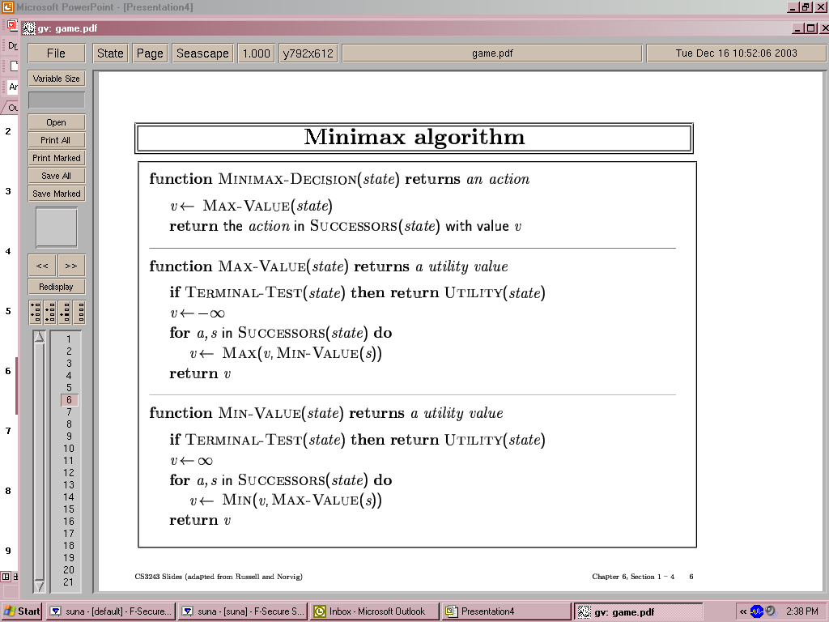Explain the following MinMax algorithm with an example.
   3. As in game environment, alpha-beta pruning algorithm is a popular alternative, give an example of application of the algorithm where it suits best.
2. 2+3+5
   1. What is the structure of a simple knowledge based-agent?
   2. 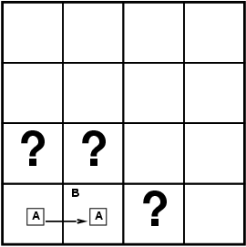 Based on the following situation of Wumpus world, i.e. situation after detecting nothing in [1,1], moving right and detecting breeze in [2,1], what will be model for next three possible move (knowledge base) assuming only pits?
   3. Explain in detail the following algorithm in order to implement inference by enumeration.

1. 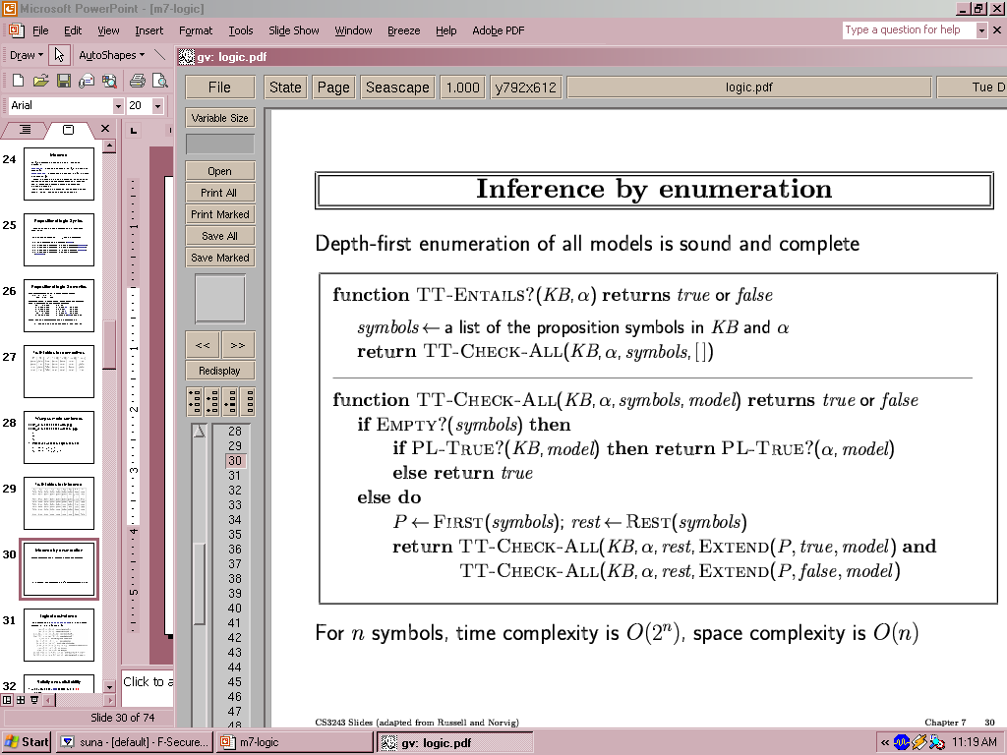 2+3+5
   1. 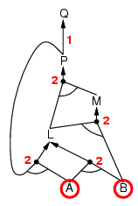 How forward chaining can be applied in case of the following example.

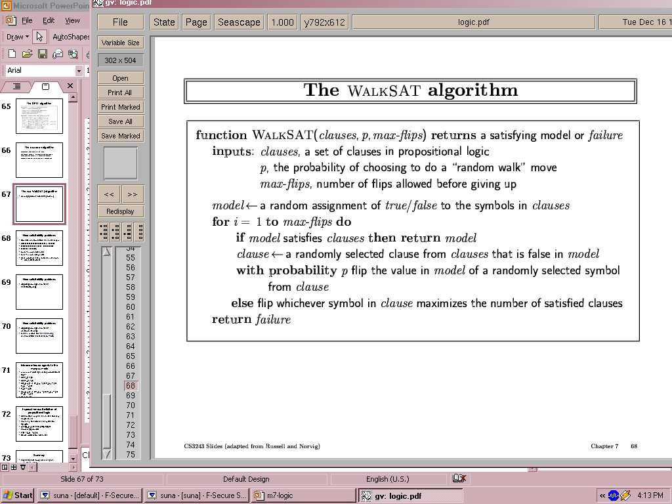

* 1. Explain the WalkSAT algorithm with example. What will be the application of this WalkSAT algorithm?
  2. 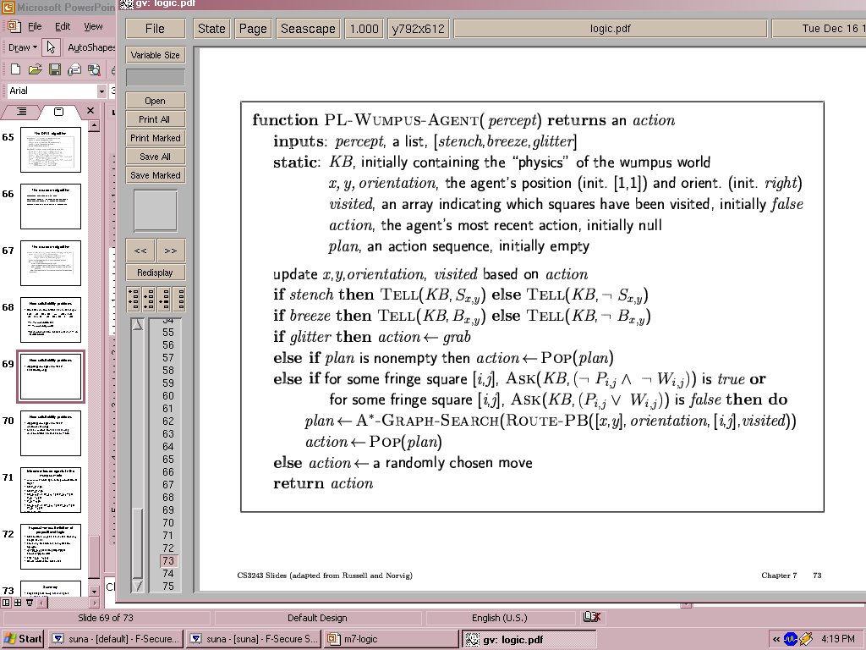 Wumpus world agent can be presented in the following algorithm. What will the agent do in order to resolve the game?

1. 2+3+5
   1. Distinguish prior and posterior probability with some examples.
   2. 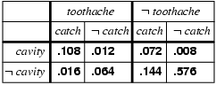 Based on following joint probability distribution, find **P(¬Toothache**).
   3. Bayes' rule is useful in practice because there are many cases where we do have good probability estimates. A doctor knows that the disease meningitis causes the patient to have a stiff neck, say, 50% of the time. The doctor also knows some unconditional facts: the prior probability that a patient has meningitis is 1/50,000, and the prior probability that any patient has a stiff neck is 1/20. Letting ***s*** be the proposition that the patient has a stiff neck and ***m*** be the proposition that the patient has meningitis. What will be the probability for meningitis provided the patient have stiff neck?
2. Write short note on
   1. Learning agent
   2. Inductive learning
   3. Learning decision tree